Sri Lanka Institute of Information

Technology



Lab Submission

Lab sheet No 7

**IT24101681**

**Senanayaka S.A.A.T.C**

**Probability and Statistics - IT2120**

Exercise

1)

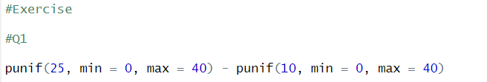

2)

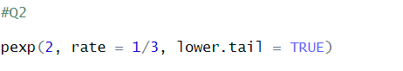

3)

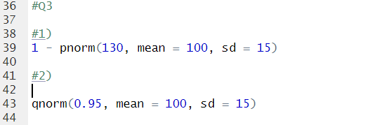

Answers:

